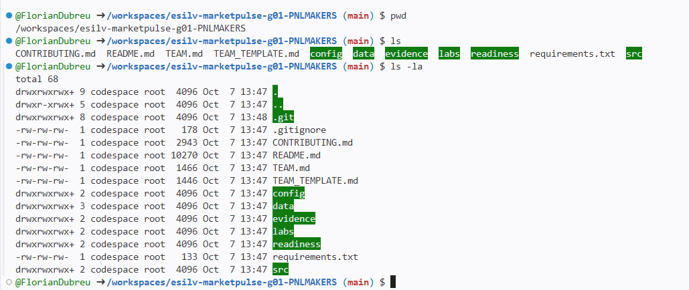
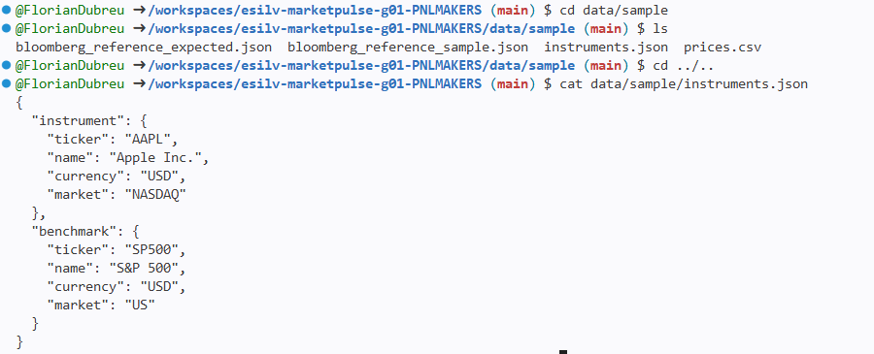
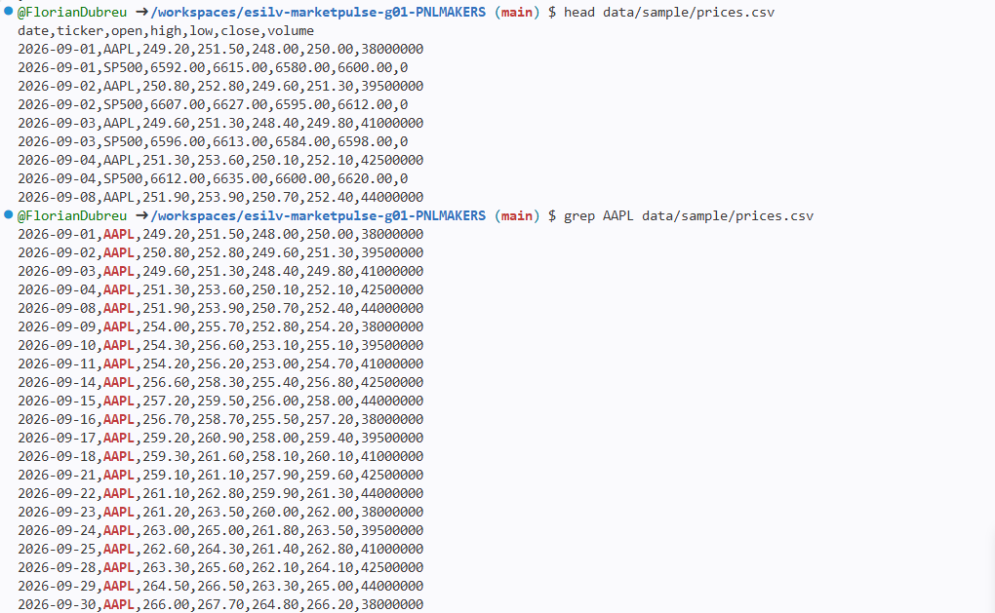
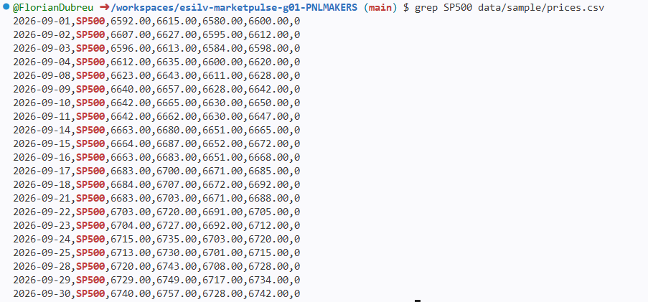
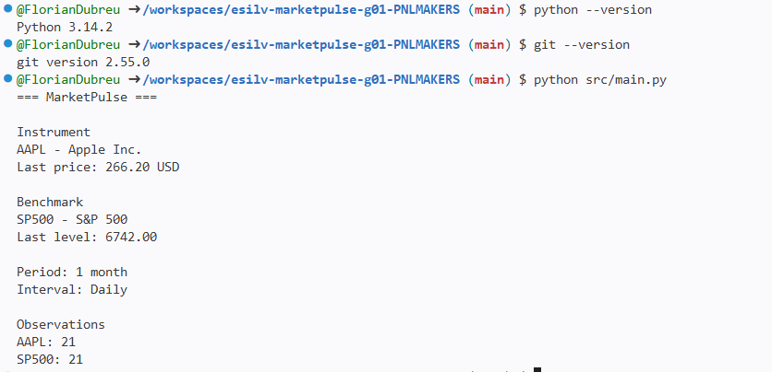

Main.py dans src :
from pathlib import Path
import csv
import json

DATA_DIR = Path("data/sample")

# These starter values mirror config/settings.yml.
# settings.yml is a human-readable configuration contract in the CORE.
# Parsing YAML is optional and is not required by the 18-hour lab sequence.
LOOKBACK_LABEL = "1 month"
INTERVAL_LABEL = "Daily"

def load_instruments():
with open(DATA_DIR / "instruments.json", encoding="utf-8") as file:
return json.load(file)

def load_prices():
with open(DATA_DIR / "prices.csv", encoding="utf-8") as file:
return list(csv.DictReader(file))

def filter_prices(prices, ticker):
return [row for row in prices if row["ticker"] == ticker]

def get_first_close(prices):
# prices[0] = première ligne, on prend "close" et on le convertit en nombre
return float(prices[0]["close"])

def get_last_close(prices):
# prices[-1] = dernière ligne
return float(prices[-1]["close"])

def display_market_summary(asset, prices, show_currency=True):
# Une seule fonction d'affichage, utilisée pour AAPL ET pour SP500
currency = f" {asset['currency']}" if show_currency else ""
print(f"{asset['ticker']} - {asset['name']}")
print(f"Observations : {len(prices)}")
print(f"First close : {get_first_close(prices):.2f}{currency}")
print(f"Last close : {get_last_close(prices):.2f}{currency}")

def main():
# 1. Charger les données
instruments = load_instruments()
prices = load_prices()

# 2. Récupérer l'instrument et le benchmark
instrument = instruments["instrument"]
benchmark = instruments["benchmark"]

# 3. Séparer les lignes AAPL et SP500
instrument_prices = filter_prices(prices, instrument["ticker"])
benchmark_prices = filter_prices(prices, benchmark["ticker"])

# 4. Afficher la configuration
print("=== MarketPulse ===")
print()
print("Market configuration")
print(f"Period : {LOOKBACK_LABEL}")
print(f"Interval : {INTERVAL_LABEL}")
print()

# 5. Afficher les deux résumés avec LA MÊME fonction
print("Instrument")
display_market_summary(instrument, instrument_prices)
print()
print("Benchmark")
display_market_summary(benchmark, benchmark_prices, show_currency=False)

if __name__ == "__main__":
main()
